Opnsense firewall installation
Step-1 when firewall boot usb after boot.
step-2 login: opnsense
Password: devray
Step-3 ssh installer@localhost
After that these step run
#By default username and passwd
Username = installer
Password = opnsense
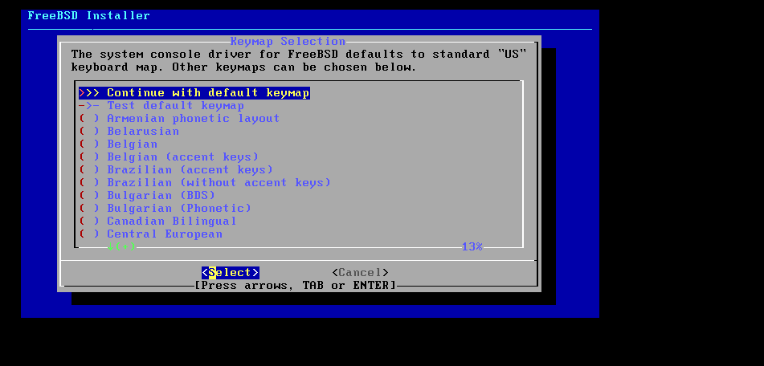
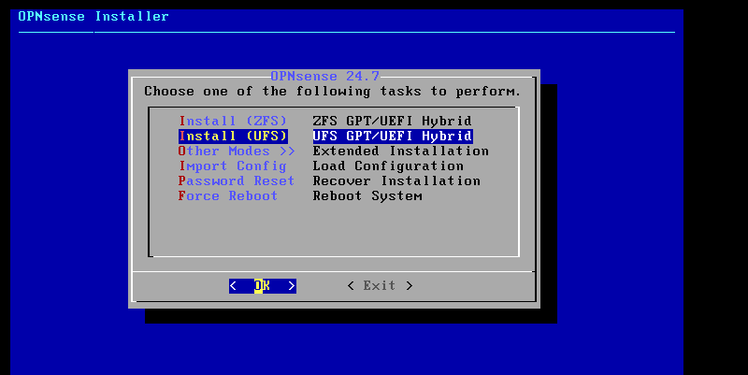
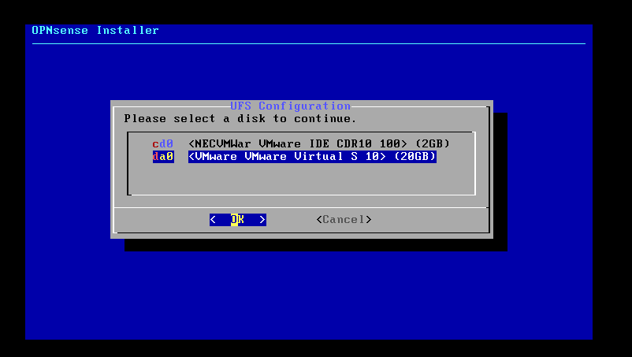
Do not select usb. Select HDD
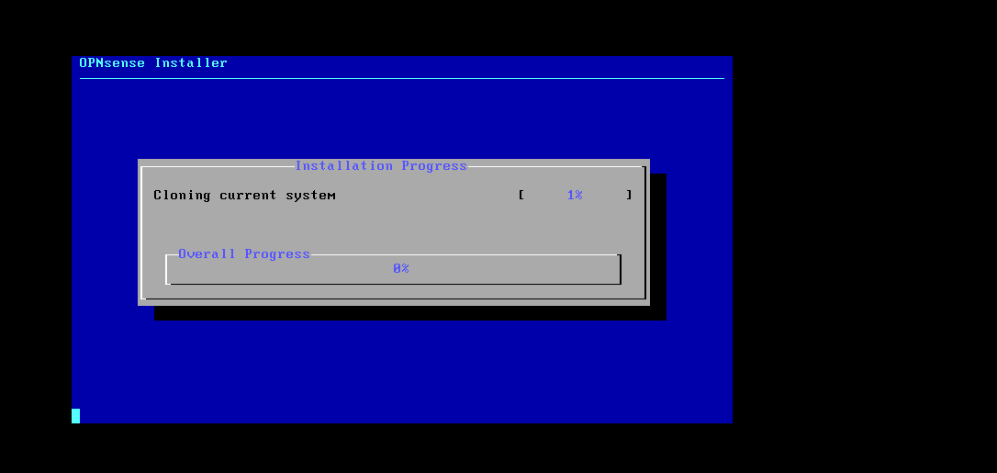
After complete this step
Use dhcp4 ip assign

New Opensense firewall installation
By default user name or password
user – installer
password – devray

